User Story Mapping Programming Forum System For College Students

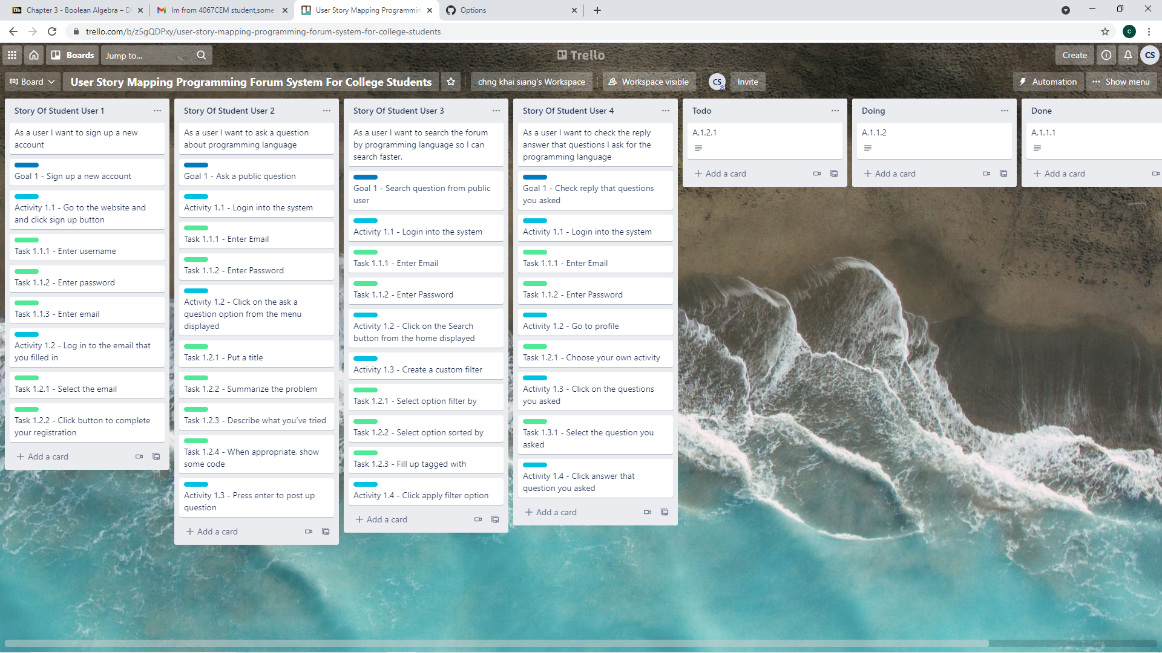

Story of student user 1

Story of student user 2

Story of student user 3

Story of student user 4

